Professional Learning Community
Introduction to Assessment Techniques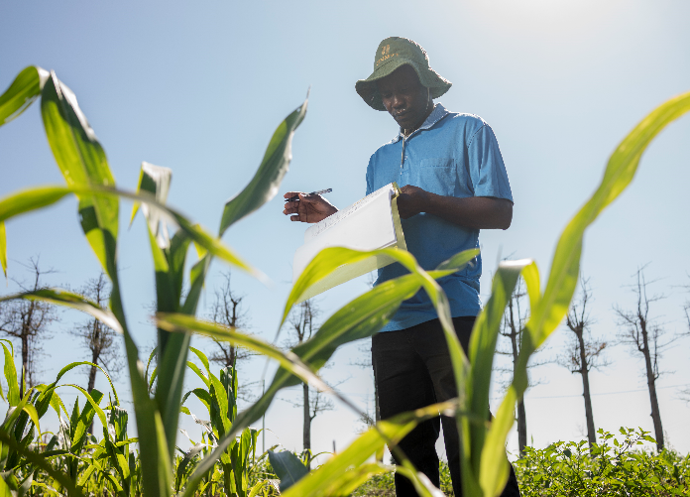

Your Name:
Position:
Background:

Prepared By:
Miranda Morris, M.S., Graduate Assistant, mmmorris@iastate.edu;
Judy Levings, Ph.D., PBEA-PLC Coordinator and Facilitator, judylevings@gmail.com
Michael Retallick, Ph.D., PBEA-PLC Director, msr@iastate.edu
Greg Miller, Ph.D., PBEA-PLC Facilitator, gsmiller@iastate.edu
Funded by:
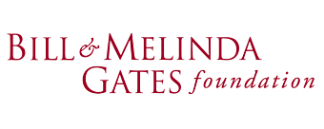
Basic Information on Plant Breeding in Africa E-Learning Modules
The goals of this project are to provide you up-to-date cutting edge content curriculum materials to you.
Reminders:
PBEA website: https://pbea.agron.iastate.edu/
PBEA Course Instructor Guide: https://pbea.agron.iastate.edu/plc/plant-breeding-e-learning-module-discussion/course-guide-pbea-molecular-plant-breeding

Professional Learning Communities Goals:
- To assist African professors with integrating the PBEA e-learning modules into their classroom curriculum
- To assist African professors with improving overall instruction

PBEA-PLC webpages to assist your instruction:
https://pbea.agron.iastate.edu/plc
Get signed in by following the login prompts. If you need assistance, contact Dr. Walter Suza at wpsuza@iastate.edu

Table of Contents
- Introduction........................................................................................ 5
Welcome........................................................................................ 5
Getting Started……......................................................................... 5
Objectives...................................................................................... 7
- Lesson Planning.................................................................................. 7
Backwards Design......................................................................... 7
ABCD Lesson Objectives................................................................ 8
Bloom’s Taxonomy........................................................................ 9
Lesson Planning Template............................................................ 10
- Types of Assessment......................................................................... 11
Designing Formative Assessment................................................ 13
Rubrics/ScoreSheets.................................................................... 14
Designing Summative Assessment ............................................. 21
MCQs........................................................................................... 23
- References…………………………………………………………………………………...27

Teaching and Learning Assessment Workbook
Welcome to the teaching and learning assessment workbook!
The Plant Breeding E-Learning in Africa Professional Learning Community has learned about preparing instruction and lecture delivery methods in the first workbook and throughout the Symposiums facilitated by Iowa State University department of Agricultural Education and Studies. The assessment module will help educators design tests, quizzes, and assignments to challenge students and help professors assess student learning.
The goal of this module will be to help instructors determine the best tools for assessment.
Getting Started:
How do I like to be assessed? What kind of testing do I prefer my instructor use?
_____________________________________________________________________________________________________________________________________________________________________________________________________________________________________________________________________________________________________________________________________________________________________________________________________________________________________________________________________________________
Why do I like to be assessed in this way? What makes it effective?
_____________________________________________________________________________________________________________________________________________________________________________________________________________________________________________________________________________________________________________________________________________________________________________________________________________________________________________________________________________________

Follow-up Responses:

In a study, U.S. students said they prefer.....
- Interviews
- Field experiences
- Lab activities
And they dislike…
- Quizzes
- Writing Papers
- Group Projects

Bailey, S., Hendricks, S., Applewhite, S. (2015). Student Perspectives of Assessment Strategies in Online Courses, Journal of Interactive Online Learning, 13-(3), 112-25
In a study of students who attended college in Ghana and Uganda they said they prefer….
Focus group sessions and interviews with graduate students in Ghana and Uganda identified a desire for on-going assessment in their classes throughout the term. Students specifically mentioned the need for more homework, practicals and quizzes. Students shared they want more feedback from their professors and want practice taking tests before the all-important mid-term and final exams. (Levings, Retallick, Morris & Miller, 2019).
“I learn from those professors that give us homework, because everything is not clear from the lecture. This helps us see the application of what we are doing.”

W

Which of these types of assessments do you use the most?

Objectives
Participants will be able to:
- Create assessments that connect directly to learning objectives
- Identify formative and summative assessment strategies to determine student learning
- Write a rubric/ grading scoring sheet and a multiple-choice question
- Review the pitfalls of writing exam questions
Part 1: Create assessments that align with learning objectives
In order to create assessments that connect to learning objectives, participants will first be required to attain knowledge of the following steps:
- Describe the steps of lesson plan creation
- Identify components of learning objectives
- Practice applying Bloom’s taxonomy to the creation of learning objective
Lesson Planning Steps Using Backwards Design
The order in which you create the lesson plan is, well backward.
You identify what you want students to learn by creating the objective first.
Identify Results and Learning Objectives

Then you figure out how you know that they learned the concept or skill or objective by assessing or evaluating student learning.
Determine Acceptable Evidence and Assessments

Then you plan what content, activities, or strategies will help you help students learn.
Plan Learning Experience and Instructional Methods

In Backwards Lesson Planning, the instructor begins designing the lesson by creating the objective first. So.....
....how do we create a learning objective?
First we need to ask ourselves,
What are the components that make up a learning objective?
Audience – the intended learner (i.e. MSc Plant Breeding Students or it could by local farmers)
Behavior- what is the student supposed to be able to do as a result of the lesson? (i.e. students should be able to label the lesson plan components, or students should be able to develop a breeding plan)
Condition- what are the resources, equipment or tools you need for students to learn this. (i.e. plant samples, spectrophotometer)
What environment do you need to place them in? (i.e. a lab on genetic diversity)
Degree- what is the acceptable level of performance? (i.e. 9 out of 10 times, without error, within 60 seconds, using information from past lectures)
Now you give it a try!
Activity: Can you identify the 4 components of a learning objective in the objective below?
Given a learning objective, faculty will identify learning objective components without error.
- What is the:
- A:
- B:
- C:
- D:
Is this objective observable and measurable? Why is this important?

As you create your lesson plan objectives and assessments, consider Bloom’s Taxonomy as a useful tool to help design thoughtful goals for your students that will access and utilize higher levels of cognition.
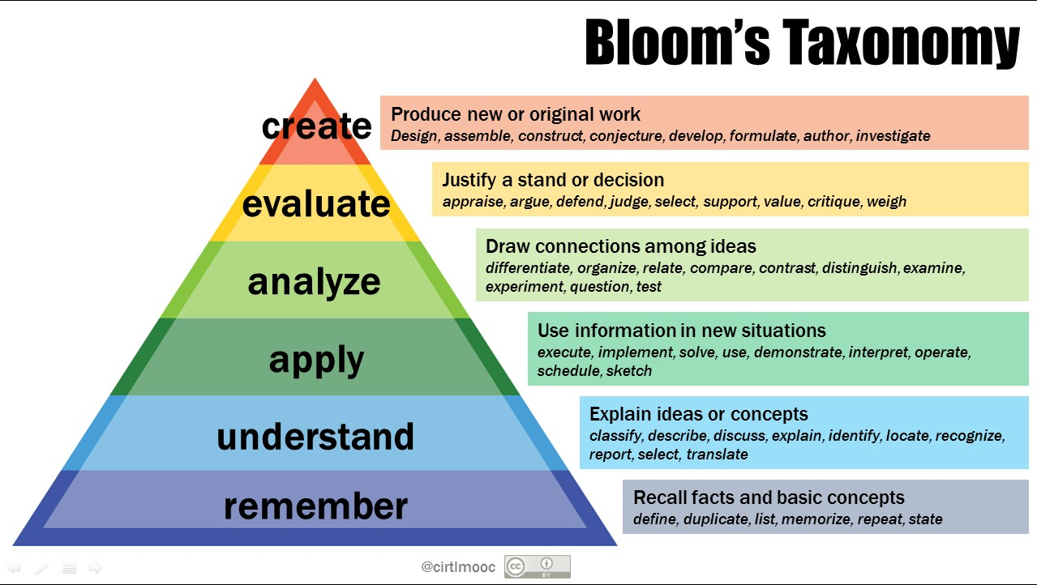
Some of your objectives will be designed to help students remember facts or basic concepts, and some will require students to apply or to analyze information. Many instructors concentrate on the lower cognition levels (remember or understand levels) in their objectives, questions or assessments. You can assist students in understanding the materials more robustly by also creating objectives using higher cognition levels (apply, analyze, evaluate, & create).
Activity
Give an example of an objective that concentrates on a lower level of cognition. __________________________________________________________________________________________________________________________________
Give an example of an objective that concentrates on a higher level of cognition. __________________________________________________________________________________________________________________________________

Lesson Planning Template
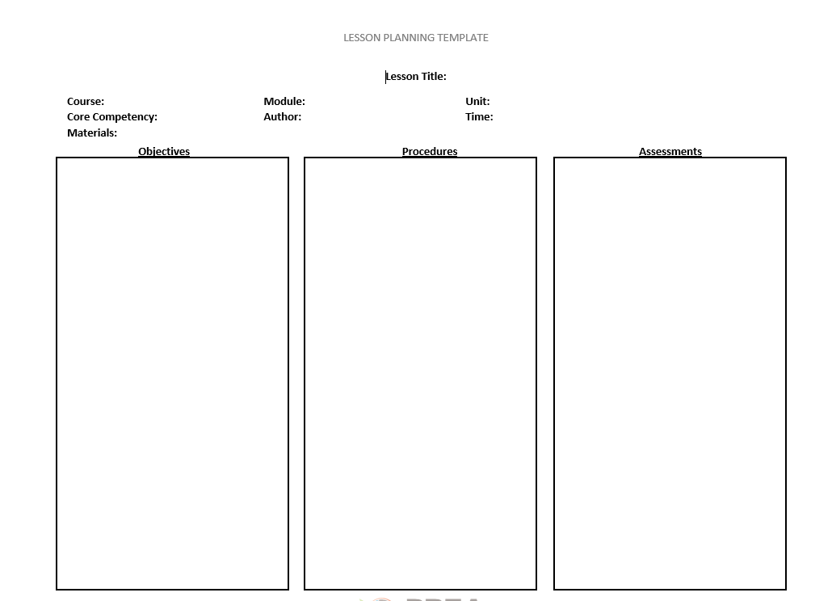
Now that you have an objective you can enter it in the lesson plan template. The template is available hard copy at the end of this module. Also a fill-in-able online form is available on the PBEA-PLC website: https://pbea.agron.iastate.edu/plc/Lesson%20Development%20&%20Delivery

Part 2: Identify formative and summative assessment strategies
In order to help determine an appropriate way to assess student learning, we need to understand the following concepts:
- Summative assessments
- Formative assessments
- When and how it is appropriate to use each.
Now let’s move on to deciding HOW we will assess our objectives.
You just identified your results and learned about learning objectives. Now let’s take a look at that assessment piece.
Identify Results and Learning Objectives

Determine Acceptable Evidence and Assessments

Plan Learning Experience and Instructional Methods

Wiggins, G. & McTighe, J. (2006). Understanding by Design. Alexandria Virginia: Association for Supervision and Curriculum Development.
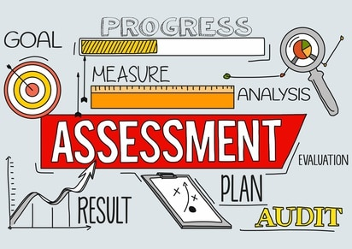
Let’s talk Assessment
Image provided by psychcentral.com
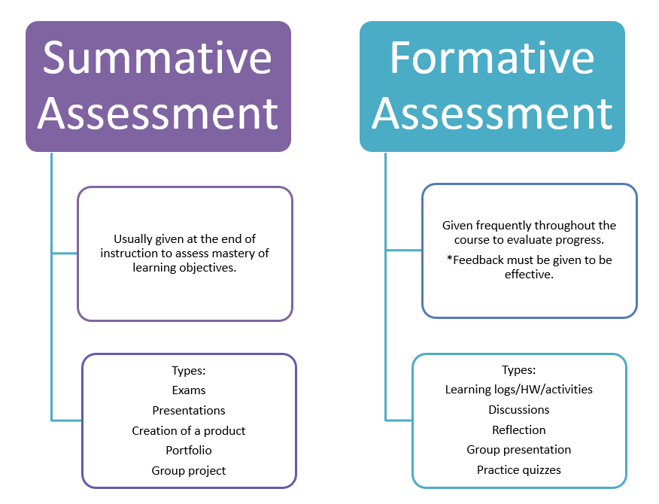
How do we know which type of assessment to use?
https://fsw.instructure.com/courses/1018292/pages/formative-and-summative-assessment

The type of assessment we chose (formative or summative) is going to be influenced by our learning objectives and what we are trying to determine.
Activity
Read each question and mark which assessment type fits with the assessment needed.
 | Formative | Summative
How can I help my student identify their strengths and weaknesses in this content area?
How can I tell if my students are ready to apply the concepts learned over several units and move onto the next topic?
Have my students internalized this material and made it a part of their identity that will stick with them throughout their education?
How can I tell if my student understands this material or if they are struggling with these concepts?
How well are students able to use the concepts, skills, frameworks I have taught them over the course of the semester?
Designing Formative Assessment
The purpose of formative assessment is to allow the teacher to make ongoing assessment of student learning to make improvements and adjustments to their teaching style and the content. Additionally, formative assessments allow students to check for understanding of materials.
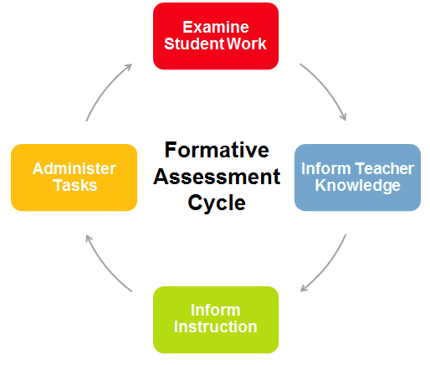
Examples of formative assessment that analyze student work/understanding:
Assignments/Homework | In-Class Assessment
Applied Learning Activities (ALAs)  Field experiences  Presentations  Lab reports | Quizzes  Questions  Tests
Some of these formative assessment assignments need to be measured in other ways besides through quizzes and tests. The difficulty is with how do students fully understand what is expected of them, and how do you know how to grade these assignments without being overly subjective. A way to assist you with this is by creating a rubric or a grading score sheet.
What is a Rubric/Grading Score Sheet? How can it help me assess my students?
Rubrics can help the instructor grade skills-based assignments like Applied Learning Activities (ALAs). They can give guidance to oral presentations and portfolios, and they give structure and clarity to tasks and activities that can might be difficult or confusing. Take a look at the sample rubric for an oral presentation below.
Sample Rubric
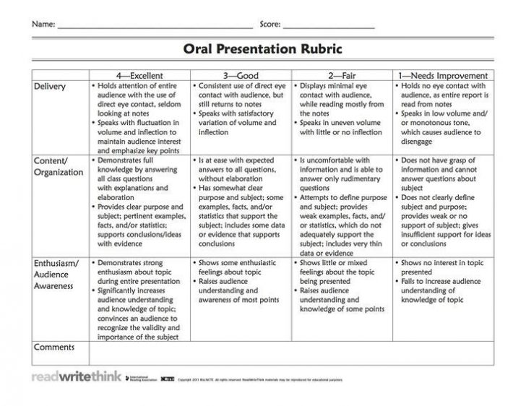
http://www.readwritethink.org/

A rubric or scoring sheet like the one pictured above would be scored out of 12 possible points. The teacher circles the box that best describes the work done by the student and then adds up all the possible points. A completed rubric might look like this:

Sample Completed Rubric

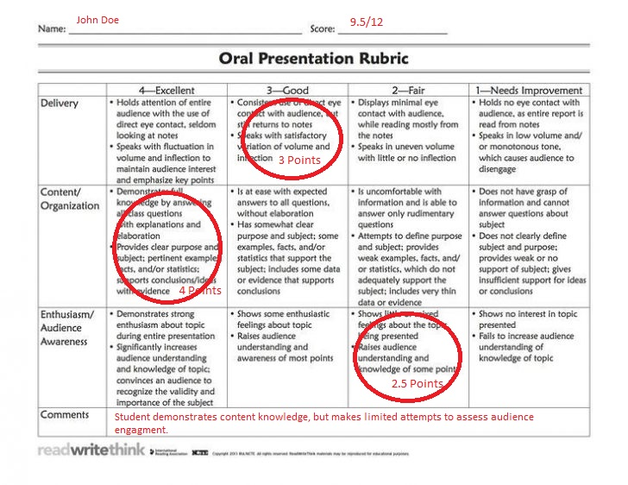
Rubrics give organization to teacher observations. The primary purpose of a rubric is to assess student performance through descriptions of areas to improve. Instead of the instructor arbitrating a grade that may or may not reflect student understanding, the rubric gives description and transparency to the behavior that is observed.

In the sample rubric, the instructor is assessing three primary criteria...

 | 4 – Excellent | 3 – Good | 2-Fair | 1 – Needs Improvement
Delivery | Holds attention of audience with the use of eye contact, seldom looks at notes. Speaks with fluctuation in volume and inflection
Content/Organization
Enthusiasm/Audience Awareness

...and placing the grading on a 4-point scale...

 | 4 – Excellent | 3 – Good | 2-Fair | 1 – Needs Improvement
Delivery | Holds attention of audience with the use of eye contact, seldom looks at notes. Speaks with fluctuation in volume and inflection
Content/Organization
Enthusiasm/Audience Awareness

...while the description in the boxes substantiates what the teacher is evaluating.

 | 4 – Excellent | 3 – Good | 2-Fair | 1 – Needs Improvement
Delivery | Holds attention of audience with the use of eye contact, seldom looks at notes. Speaks with fluctuation in volume and inflection
Content/Organization
Enthusiasm/Audience Awareness

So how do I design a quality rubric?
Step (1) Identify what I want to assess.
Step (2) Identify how well I want my students to know the material.
Step (3) Describe the best/worst outcomes from your students and place into your categories.
Step (4) Describe your developing stages of student outcomes.
Let’s design a rubric together!
Activity
Step (1) Identify what I want to assess. Write 3-5 criteria for assessment that you want your students to demonstrate.

- _________________________________________________________
- _________________________________________________________
- _________________________________________________________
- _________________________________________________________
- _________________________________________________________

Now add your criteria to the greyed-out section of the chart on the next page.

Practice Rubric #1

Let’s move onto Step (2) Identify how well I want my students to know the material. For this assignment, we are going to fill in the chart for you with 3 possible points on the grading scale for each criterion.

 | 3 – Good | 2- Fair | 1 – Poor

Move your first criteria down to the table.
Step (3) Describe the best/worst outcomes from your students and place into your categories.
 | 3 – Good | 2- Fair | 1 – Needs Improvement
 | Best: |  | Worst:

And finally, Step (4) Describe your developing stages of student outcomes.

 | 3 – Good | 2- Fair | 1 – Needs Improvement
 |  | Developing:

Complete your rubric by adding descriptions of outcomes to all your criteria.

When creating rubrics, remember....
- Align your criteria and outcomes to your lesson objectives.
- The rubric needs to evaluate what you say you are going to evaluate.
- Students should see the rubric prior to assessment!
Other Formative Assessments
Often formative assessments can be tied to class activities. These activities or assessments can help you identify a student’s errors in thinking and can serve to help students practice using the information you have just covered in class in a novel way. Many learner-centered methods can assist you with this (see the Lesson Planning and Improving Lectures Guide). These activities may include:
- Asking students to answer 3-5 quiz questions, right after presenting a topic. Using a live interactive audience response system like KaHoot (https://kahoot.com/ or Poll Everywhere https://www.polleverywhere.com/ can make this fun and appealing to students.
- Asking students questions about the topic in think-pair-shares.
- Asking students to write a Minute-Paper about a question that covers student understanding of the material in class.
- Asking students to perform a task or homework during your lecture period and quickly reviewing student understanding as you walk around the room.

Designing Summative Assessments
The purpose of summative assessment is to allow the teacher to make assessment of mastery of content in student learning. Additionally, summative assessments allow instructors to evaluate course objectives and big picture activities.

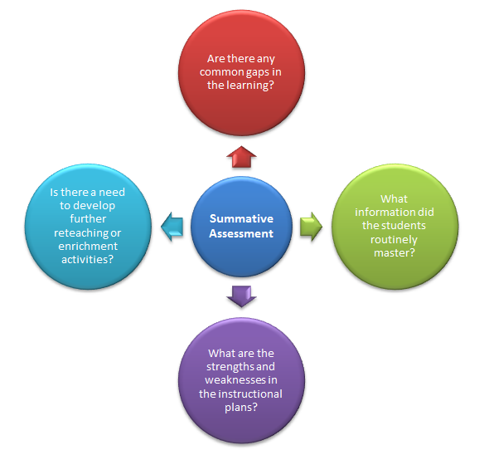
https://sites.google.com/site/decodingdifferentiation/assessment/summative-assessment
Examples of Summative Assessment:
- Final Exams
- Portfolios
- Capstone projects

Portfolios and capstone projects can be graded using a rubric as described earlier. Midterm and final exams are what professors usually use as their summative assessment of student learning. The effectiveness of the assessment you design largely depends on:
- Does the test produce consistent results? This is known as reliability.
- Does the test measure what it was designed to measure? (course and lesson objectives). This is validity.
- Does the test achieve its purpose? This is known as usability.
What about Reliability?

What would make a car unreliable?

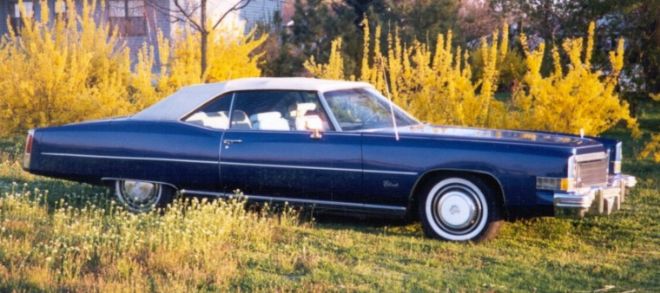
What would make an exam unreliable? 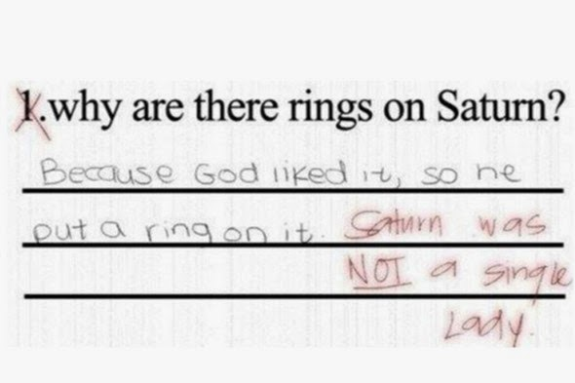
Generally, reliability issues are errors of design and construction, as well as errors in operation/administration and maintenance and scoring.
With exams-
- If you offer two versions of the test, both after scoring should have the same mean and variance.
- Check your test questions for outliers (only a few can answer the questions) and those that are answered by everyone.
What about validity?
Does the test measure what you want it to, how are the questions written- are they easy to understand or are they ambiguous, are you tripping students up with your choice of response options, etc. __________________________________________________________________
An easy way to check for validity is after you create the test, check back to the objectives in your lesson plans. Are you testing over these or something else?

Part 3: Designing MCQs (Multiple Choice Questions)
One of the best ways to improve the validity, reliability and usability of your exam is by writing good questions.
Good exam questions can stimulate the highest level of student cognitive development.
In this section you will:
- Review the pros and cons of using a multiple choice exam
- Identify tools to help evaluate student learning
- Create assessment materials to inform instructor course creation
When designing a multiple choice exam or quiz, it is important to keep the advantages and disadvantages of development in mind.
Pros | Cons
- Cover large amounts of material quickly  - Flexible for measuring different levels of complexity  - Efficient and objective in scoring | - Time consuming to develop  - Assume one right answer  - Difficult to measure innovation, creativity, or complex problem solving

What are some other advantages or disadvantages to multiple choice questions?
_______________________________________________________________________________________________________________________________________________________________________________________________________________________________________________________________________________________________________________________________________________
If the multiple choice question is the right design for assessment, the anatomy of the question should fit the following format:

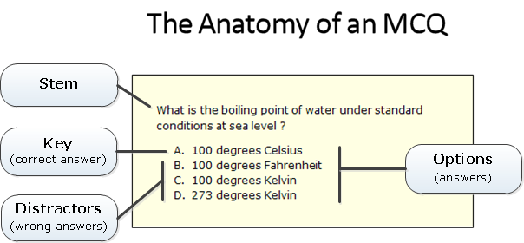
Image from http://www.intelligentassessment.com/examonline/examonline-resources/writing-good-mcqs/

The multiple choice stem should:
- Clearly define the task
- Measure specific content
- Be at the intended level of complexity
- Be unambiguous
- Avoid negative questions

Activity
Consider the assessment objectives that you created earlier. Design one multiple choice stem that clearly defines the task set by your objective.
__________________________________________________________________________________________________________________________________
Share that stem with a peer. Consider the following questions:
- Why do you think it is well constructed?
- What does your peer think?
- Make notes of things you can do to improve the stem.

The multiple choice responses should:
- Have multiple options
- Avoid overlapping options
- Use fewer words (students will guess the longer answer is correct).
- Have random correct answer locations
- Not purposely chosen to trip up student thinking
- Have no more than 4 choices
Activity
Create multiple options that answer your stem questions. Ensure that they follow the rules outlined above. __________________________________________________________________________________________________________________________________
Share your responses with a peer. Consider the following questions:
- Why do you think it is well constructed?
- What does your peer think?
- Make notes of things you can do to improve the responses.

Overall Writing Good Multiple Choice Question Test Rules
- Consult Blooms Taxonomy verb sheet to assist in creating higher-order questions.
- Grammar should be consistent.
- Responses similar in length.
- Four response options used consistently throughout.
- Begin with easy questions and progress to more complex.
- Correct answers randomly distributed.
- Avoid the following options: All; None; A and B, or C and D is correct.
- Negative words highlighted (if the questions are mostly positively worded, students tend to not read the negative word). The goal is to find out if students understand a concept, not to trick them.
- Distractors should be plausible, familiar, not obviously incorrect.
Resources: https://cft.vanderbilt.edu/guides-sub-pages/writing-good-multiple-choice-test-questions/

Other Tools to Evaluate Student Learning
Remember that the goal of summative assessment is to evaluate student learning at the end of a unit by comparing it against a standard or benchmark.
These assessments can take the form of research reports, powerpoint presentations, posters, videos, etc. To assess these effectively please refer to the Rubrics or Grading Score Sheet section.

Test Question Banks
Many professors can help each other by using a content management system such as Canvas, Moodle, or Blackboard to house their quizzes and tests. Some of these systems allow colleagues to share their text banks with each other. This can be helpful with viewing how other colleagues word higher-order questions. Check with your Universities IT Department to see if and what content management system they support.
Canvas- https://canvas.instructure.com/login/canvas
Moodle-https://moodle.org/
Blackboard- https://www.blackboard.com/index.html

References:
Bailey, S., Hendricks, S., Applewhite, S. (2015). Student Perspectives of Assessment Strategies in Online Courses. Journal of Interactive Online Learning, 13-(3), 112-25
Chapman, C. & King, R. (2012). Differentiated assessment strategies: One tool doesn’t fit all. Thousand Oaks, CA: Corwin.
Florida SouthWestern College. (2019). Formative and Summative Assessment. Retrieved from https://fsw.instructure.com/courses/1018292/pages/formative-and-summative-assessment
Vanderbilt University. (2019). Writing Good Multiple Choice Test Questions. Retrieved from https://cft.vanderbilt.edu/guides-sub-pages/writing-good-multiple-choice-test-questions/
Wiggins, G. & McTighe, J. (2006). Understanding by Design. Alexandria, VA: Association for Supervision and Curriculum Development.

