ALA 2.1 Calculation of genetic relationships based on DNA marker information
Prerequisite
Understanding required for:
- Importance of DNA sequence variation within species
- RFLP, SSR and AFLP as examples of classical markers
- SNP and INDEL markers basics
- Basic applications of markers: fingerprinting and gene-tagging
Purpose
Provide understanding of the steps needed to convert DNA fingerprint information into a cladogram.
Background
Understanding the relationships among lines or genotypes of a breeding population or other germplasm are important in various contexts: establishing heterotic groups for hybrid breeding; selection of parents to develop breeding populations; variety protection; identification of duplicates in germplasm collections; among others. DNA markers are a useful tool to determine and quantify genetic relationships.
Tasks
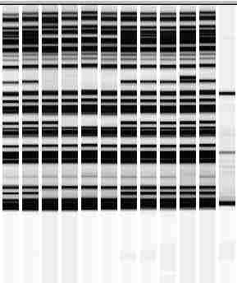
Figure 1. AFLP electropherogram. Columns 1-11 show AFLP fingerprints of 11 different genotypes. Column 12 is a size standard, and can be ignored for further calculations. AFLP fingerprints were generated using the same restriction enzymes and primer combination, and can thus be directly compared across the 11 genotypes.
- Convert AFLP fingerprints into a 1-0 data matrix (for each genotype – band combination: a “1” signifies “band present”, a “0” “band missing”)
- Determine “genetic similarity” (fraction of number of bands in common / all bands) for each pair of genotypes. Display genetic similarities in a matrix.
- Provide a brief explanation, what you are doing in tasks 1 and 2.
- Repeat 1-2 for two scenarios (you already completed one of the two above): include and exclude monomorphic DNA marker bands. How do these two scenarios differ, and why ?
- Assume, the 11 genotypes are either highly heterozygous, or inbred lines – how does it affect interpretation of your cluster analysis ?

Tentative answers (can differ, based on context / assumptions made)

