ALA 1.1 Characteristics of main types of varieties
Prerequisites
eModules_1-5 in Principles of Plant Breeding and Crop Improvement
Purpose
- Reinforcement of intuitive understanding of the major discriminating features of the four main types of varieties: clone, line, population, and hybrid varieties.

Background
The essence of breeding methodology is to understand the main features of variety types. These features determine, which conventional or molecular methods can or cannot be used.
Tasks
- Fill out the correct terms in Table 1 below.
- Discuss for each of the four features, which of the variety types has advantageous or disadvantageous properties. Note, that this might differ depending on the perspective (plant breeders, farmers).
- In what circumstance could uniformity of varieties not be seen as an advantage?
- How can the ability to reproduce varieties be favorable to farmers, yet undesirable for plant breeders ?
- The mode of reproduction impacts to a large degree, which type of variety is most convenient for a given crop species. What is needed to transition a particular species from one to another type of variety ? Do you know examples ? What is the rationale for transitioning to another variety type ?
- Table 1 highlights differences between the four main types of varieties. What do all four types of varieties have in common ?

Table 1. Modes of propagation and genetic structure of four main types of varieties.
 | Type of Variety
Features | Clone | Line | Population | Hybrid
Mode of propagation
(sexual, asexual)
Heterozygosity
Heterogeneity
Reproduction by farmer possible ?

Tentative answers (can differ, based on context / assumptions made)

 | Type of Variety
Features | Clone | Line | Population | Hybrid
Mode of propagation  (sexual, asexual) | Asexual | Sexual | Sexual | Sexual
Heterozygosity | Heterozygous | Homozygous | Heterozygous | Heterozygous
Heterogeneity | Homogeneous | Homogeneous | Heterogeneous | Homogeneous
Reproduction by farmer possible ? | Yes | Yes | Yes | No

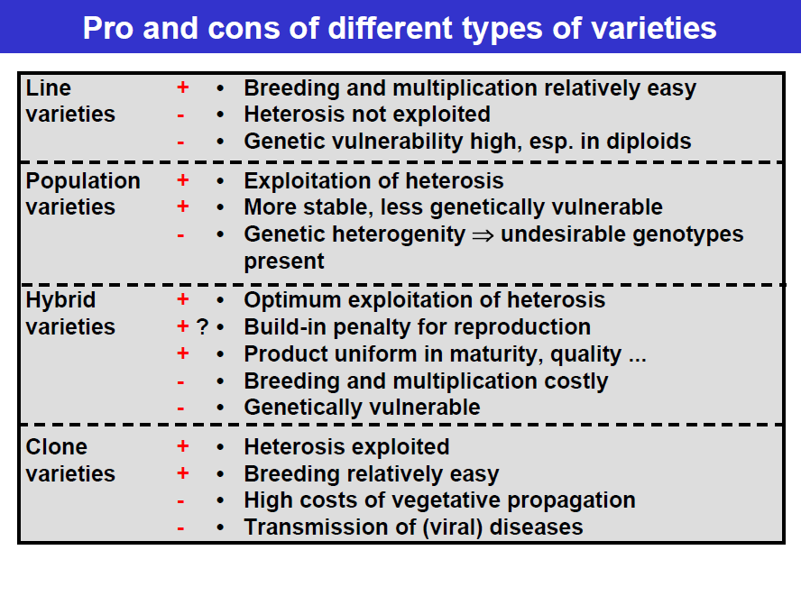

- Uniformity of varieties is generally seen as advantage. However, under low input conditions and/or with high disease pressure, this concept needs in my opinion be questioned. Heterogeneous varieties might not have best performance under optimal conditions, but a better yield stability, as there is a higher chance that at least some genotypes within such a variety tolerate adverse conditions (while a single genotype in uniform varieties might fail completely).

- The ability to reproduce varieties is favorable for farmers. They can just keep part of the harvest and plant it out next season again. This is undesirable for plant breeders, because they lose control over their variety. Conversely, breeders are quite happy with hybrid varieties, as reproduction leads to inbreeding depression – farmers can only reproduce, while facing reduced performance. Thus, hybrids have a built-in biological protection mechanism from breeders perspective.

- While species align with variety types based on their mechanism of propagation (self pollinating species are usually line varieties, vegetatively propagated species are usually clone varieties), it is possible to move a species from one to another variety type. Standard for maize were population varieties, before it became a hybrid crop. Similarly, rice and wheat (and tomato) are migrating from line to hybrid varieties. With efficient in vitro multiplication methods, both self or foreign pollinating species may be propagated as clone varieties. In short, this can be pursued in a systematic manner, to harness the advantages of a particular type of variety. Could perhaps be of interest for comparatively “young” or orphan crop species – rather than just using the “natural” propagation and type of variety. In most cases of variety type transition, it is (a) from heterogeneous to homogeneous types of varieties to accomplish uniformity (b) or to highly heterozygous variety types to maximize exploitation of hybrid performance and heterosis (multiply the one best (heterozygous) genotype).

- In common for all variety types is: setting breeding objective(s), generate genetic variation, develop variety parents (such as inbred lines of hybrids), evaluate experimental varieties, registration and maintenance of varieties.

